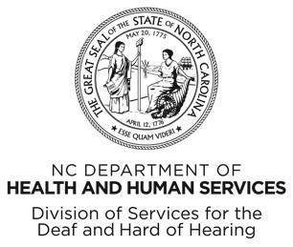
Relay NC proudly celebrates 35 years of providing telecommunications services for people with
hearing loss or speech disabilities!
SpringFest
Saturday, May 17, 2025
10 a.m. – 2 p.m.
Embassy Suite by Hilton
201 Harrison Oaks Blvd.,
Cary, NC 27513

- Hot Lunches Provided
- Caricature Drawings
- Fun Photo Booth
- Slide & Video Shows

For more information or to RSVP by May 12th,
go to relaync.com/35-event or scan the QR code.



